Project Design Phase-II
Technology Stack (Architecture & Stack)

Date | 16.11.2022
Team ID | PNT2022TMID07412
Project Name | Project – Web Phishing Detection
Maximum Marks | 4 Marks

Technical Architecture:
The Deliverable shall include the architectural diagram as below and the information as per the table1 & table 2

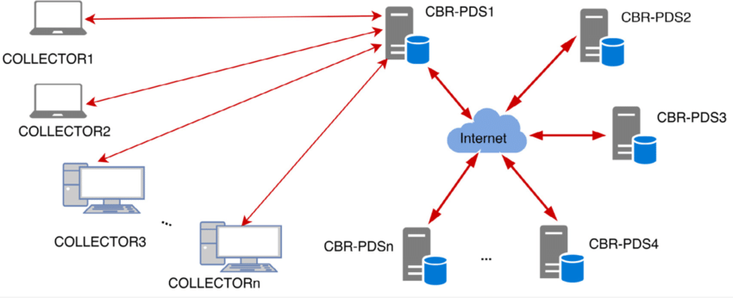

Table-1 : Components & Technologies:

S.No | Component | Description | Technology
1. | User Interface | How user interacts with application e.g. Web UI, Mobile App, Chatbot etc. | HTML, CSS, JavaScript / Angular Js / React Js etc.
2. | Application Logic-1 | Logic for a process in the application | Java / Python
3. | Application Logic-2 | Logic for a process in the application | IBM Watson STT service
4. | Application Logic-3 | Logic for a process in the application | IBM Watson Assistant
5. | Database | Data Type, Configurations etc. | MySQL, NoSQL, etc.
6. | Cloud Database | Database Service on Cloud | IBM DB2, IBM Cloudant etc.
7. | File Storage | File storage requirements | IBM Block Storage or Other Storage Service or Local Filesystem

Table-2: Application Characteristics:

S.No | Characteristics | Description | Technology
1. | Open-Source Frameworks | Gopish is a powerful, open-source phishing framework that makes it easy to test your organization's exposure to phishing. | Machine Learning.
2. | Security Implementations | Our prototype currently includes a C#.Net implementation of a web browser. | Cofense PDR (Phishing Detection and Response)
3. | Scalable Architecture | Scalability is maximum due to accurate estimation. | jQuery, cloud flare, Bootstrap.
4. | Availability | Mostly available methods for detecting phishing attacks are blacklists/whitelists, natural language processing, visual similarity, rules, machine learning techniques | Ghost Phisher, King Phisher.
5. | Performance | We assessed the performance of the phishing classification models employing accuracy, precision, recall and F-score. | Hardware and support systems, software applications.

